# 

# **Perfion office Add-In UI upgrade**

## Suggestions

## 1. Adding refresh button or Status line inside the “Perfion service” dropdown menu

PERFION COTROL: pccDefaultsControl

BENEFITS OF IMPROVEMENT: Status info if service is down in middle of user work, if service is loading content, waiting for service respond. Also it reduces needed user clicks e.g.

FUNCTIONALITY DESCRIPTION: This menu should have some new events which will take action when user sets or moves out of the focus. In menu should be some text or extra button that will show what the status of the Perfion service is.

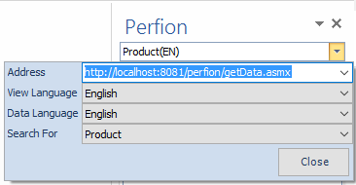

## 2. Status line about search report in bottom of the Result list table

PERFION COTROL: resultsTab

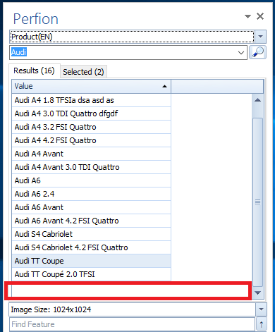BENEFITS OF IMPROVEMENT: User knows retrieved number of the query result and he can make better decision on what to search next for it (very useful for DB with big amount of entry’s).

FUNCTIONALITY DESCRIPTION: in red marked field should be introduced new status line which will contain number of results, time of the query results, total Execution Time, view order, indexing e.g. Basic info like is provided in API query.

Paging is not recommended.

## 3. retrieving back drag and drop functionality on the property Table List.

PERFION CONTROL: propertyTableList

BENEFITS OF IMPROVEMENT: User can select one or more propertys of selected Product, drag it to want position on Office page and dropt it.

FUNCTIONALITY DESCRIPTION: Previously this feature has been included in past releases but it has been excluded because it was not tested enough to cover high risk bugs. Extra testing is needed to cover all possible threads which could occur.

## 4. Managing CTRL+A double click functionality

PERFION COTROL: resultsTab

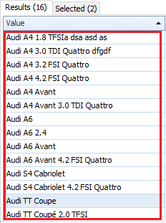BENEFITS OF IMPROVEMENT: User can easy select all searched elements in Product list and by double click adding them to the selected tab.

FUNCTIONALITY DESCRIPTION: User needs first some search results, and if he wants to add all entries in Selected tab he can do that by typing the hotkey and not selecting one by one.

## 5. Managing ENTER key functionality

PERFION COTROLs: propertyTableList

BENEFITS OF IMPROVEMENT: User can easy select all elements in Property list and by pressing ENTER property.

FUNCTIONALITY DESCRIPTION: This functionality is not supported but is useful if user uses more keyboard the mouse for inserting the single values from table to page.

## 6. Managing CTRL+A, CTRL+C, CTRL+V functionality

PERFION COTROL: resultsTab

BENEFITS OF IMPROVEMENT: User can easy select all elements in Property list and by double click or by CTRL+V option it can paste information on wanted office page/sheet position.

FUNCTIONALITY DESCRIPTION: This functionality is working a little bit different then selecting the property’s and double click.

## 7. Removing products from selected tab

PERFION CONTROL: selectedTab

BENEFITS OF IMPROVEMENT: In case where user has mistakenly made wrong choice by adding unwanted product from Results tab, he can easy remove this product just by selecting him and typing the DEL button.

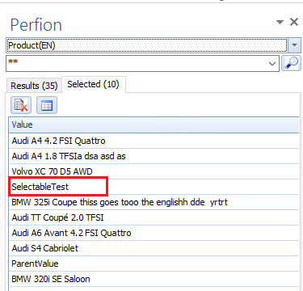FUNCTIONALITY DESCRIPTION: If user wants to remove products from selected products list he can only do that by clicking the “Clear comparisons” button. This will remove all selected products from list. This kind behavior is not suggestive if user has madden list from multiple different search choices.

## 8. Table designer improvement

PERFION CONTROL: Table Builder – FeatureCtrl popup control

BENEFITS OF IMPROVEMENT: user can see full size of the Feature selection pup-up menu and use None button to unselect all feature types

FUNCTIONALITY DESCRIPTION: Noon button will not unselect all selected features in list in some situations. Also in some rare situations extra column is added after selection columns from the list or running the insert table command.

### 8.1. In Property list Units values are shown but not in the table designer, they are also missing when we make insert table action.

### 8.2. Double click action always seems to refer to an active cursor – which led to the point, that we could not insert any texts or images in PowerPoint, without opening a text window first.

-. Introducing advanced searching

Discusion needed

9. Redefining row header of the inserted table in the Power Point

PERFION CONTROL: addSelectedToShoppingCart()

BENEFITS OF IMPROVEMENT: Its small change, which will provide better look

FUNCTIONALITY DESCRIPTION: When we inserting multiple rows in Powerpoint, first row should contain column names Feature and Value.